EXPT NO: 6 | IMPLEMENTATION OF LSTM FOR SENTIMENT ANALYSIS
DATE: | IMPLEMENTATION OF LSTM FOR SENTIMENT ANALYSIS

PRE-LAB QUESTIONS (PROVIDE BRIEF ANSWERS TO THE FOLLOWING QUESTIONS)

- What is the purpose of Long Short-Term Memory (LSTM) networks in NLP?
LSTM is a type of Recurrent Neural Network (RNN) used in NLP to process sequential data. It can remember important information from earlier words and use it to understand the context of a sentence.
- Why is LSTM preferred over a Simple RNN for processing long text sequences?
LSTM is preferred because it can remember information for a longer time using its memory cell and gates. It reduces the vanishing gradient problem that commonly occurs in Simple RNNs.
- What is sentiment analysis? Give two real-world applications.
Sentiment analysis is the process of identifying the emotion or opinion expressed in a text, such as positive, negative, or neutral.
Applications:
- Analyzing customer reviews.
- Analyzing opinions on social media.
- Explain the role of tokenization and padding in text preprocessing.
Tokenization converts text into smaller units called tokens, usually words, and then converts them into numerical values.
Padding makes all sequences have the same length by adding extra values, usually zeros. This allows them to be given as input to an LSTM model.
- What is word embedding? Why is it useful for sentiment analysis?
Word embedding represents words as dense numerical vectors that capture relationships and similarities between words. It is useful for sentiment analysis because the model can learn meaningful relationships between words and their sentiment.

AIM
To implement a Long Short-Term Memory (LSTM) network for sentiment analysis by performing text preprocessing, tokenization, sequence generation, and embedding using NLP libraries, and classify text into sentiment categories.

SOFTWARE REQUIREMENTS
- Python
- TensorFlow / Keras
- Google Colab
- GitHub
- NumPy
- Pandas
- Matplotlib
- NLP libraries – NLTK / spaCy
- Scikit-learn

OBJECTIVES
Students will be able to:
- Understand the architecture and working of LSTM networks.
- Perform text preprocessing techniques for sentiment analysis.
- Tokenize and convert textual data into numerical sequences.
- Generate word embeddings for textual data.
- Build and train an LSTM model for sentiment classification.
- Evaluate the performance of the trained LSTM model.
- Analyze the effect of preprocessing and embedding on sentiment classification.

PROCEDURE
PART A: DATASET PREPARATION AND TEXT PREPROCESSING
- Perform the following tasks:
- Load a sentiment analysis dataset such as the IMDB Movie Reviews dataset.
- Explore the dataset and examine sample positive and negative reviews.
- Check the number of samples and sentiment class distribution.
- Perform text preprocessing using NLP libraries.
- Convert text to lowercase.
- Remove unnecessary punctuation and special characters.
- Remove stop words, if required.
- Tokenize the reviews into words/tokens.
- Convert the tokens into numerical sequences using a tokenizer.
- Build a vocabulary from the training reviews.
- Apply sequence padding to obtain equal-length input sequences.
- Encode sentiment labels into numerical form.
- Split the prepared dataset into training and testing/validation datasets.
(CODE: CONATAINS STUDENT ROLL NOS
SCREENSHOT OF CODE
SCREENSHOT OF OUTPUT)

PART B: EMBEDDING GENERATION
Perform the following tasks:
- Generate numerical representations of the pre-processed text.
- Create an Embedding layer using Keras/TensorFlow.
- Define the vocabulary size and embedding dimension.
- Convert tokenized sequences into dense vector representations.
- Display the shape of the generated embedding representation.
- Analyze how words are represented in the embedding space.
(CODE: CONATAINS STUDENT ROLL NOS
SCREENSHOT OF CODE
SCREENSHOT OF OUTPUT)

PART C: IMPLEMENTING THE LSTM MODEL
Perform the following tasks:
- Create an input layer for the padded text sequences.
- Add an Embedding layer to generate dense word representations.
- Add an LSTM layer to learn sequential dependencies in the reviews.
- Add a Dense output layer with an appropriate activation function for sentiment classification.
- Compile the model using:
  - Appropriate optimizer
  - Binary cross-entropy loss
  - Accuracy as the evaluation metric
- Display the model architecture and summary.
(CODE: CONATAINS STUDENT ROLL NOS
SCREENSHOT OF CODE
SCREENSHOT OF OUTPUT)

PART D: MODEL TRAINING AND SENTIMENT PREDICTION
Perform the following tasks:
- Train the LSTM model using the prepared training dataset.
- Validate the model using the validation dataset.
- Record:
  - Training accuracy
  - Validation accuracy
  - Training loss
  - Validation loss
- Visualize:
  - Accuracy vs. Epoch
  - Loss vs. Epoch
- Evaluate the trained model using the test dataset.
- Predict the sentiment of sample reviews.
- Compare the predicted sentiment with the actual sentiment.
- Calculate appropriate evaluation metrics such as:
  - Accuracy
  - Precision
  - Recall
  - F1-score
  - Confusion matrix
(CODE: CONATAINS STUDENT ROLL NOS
SCREENSHOT OF CODE
SCREENSHOT OF OUTPUT)
CODE:
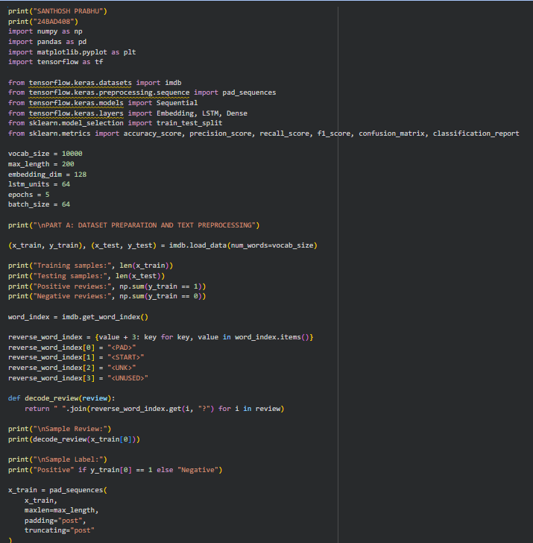

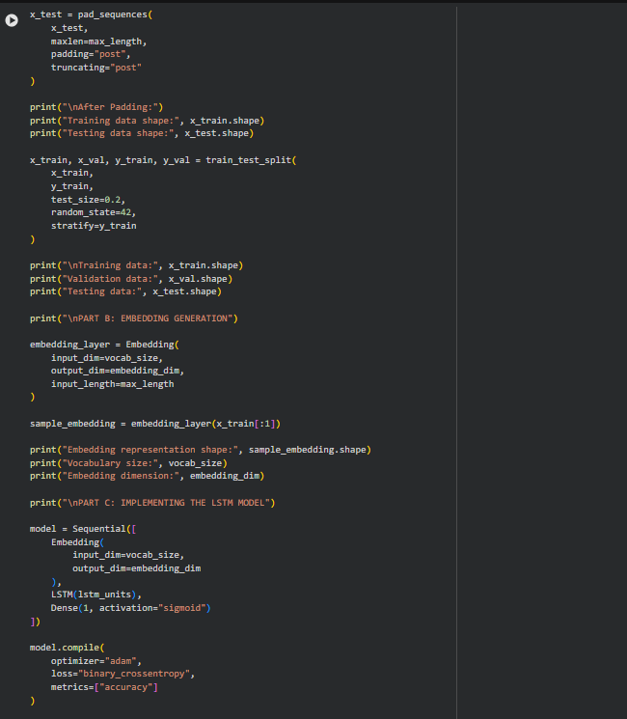

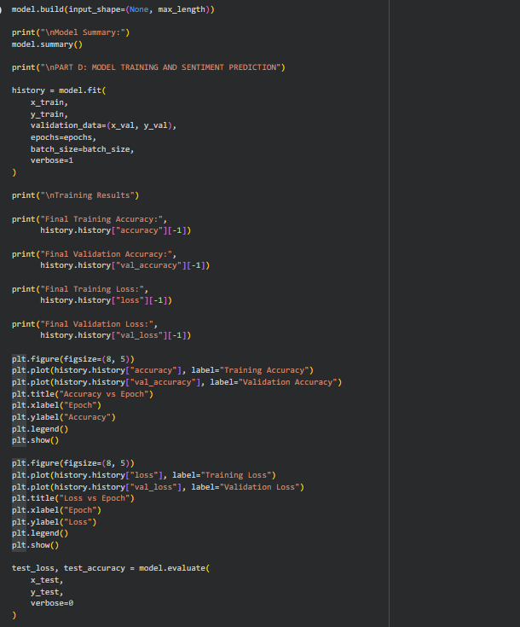
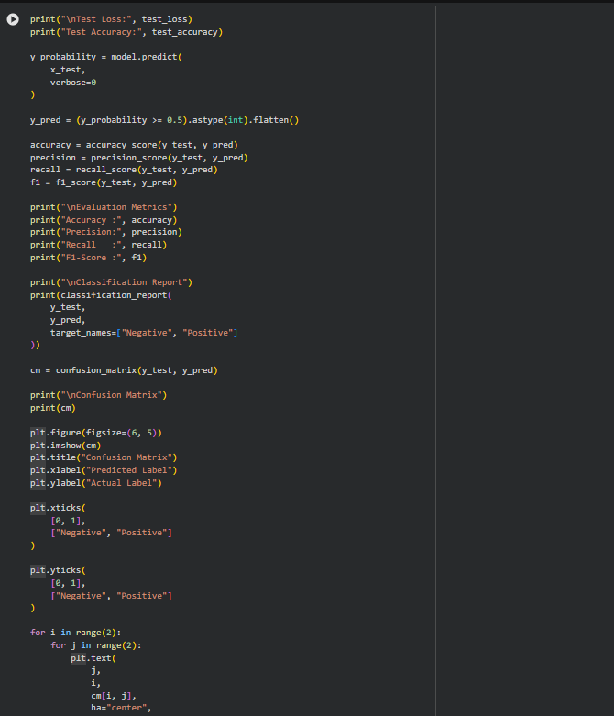

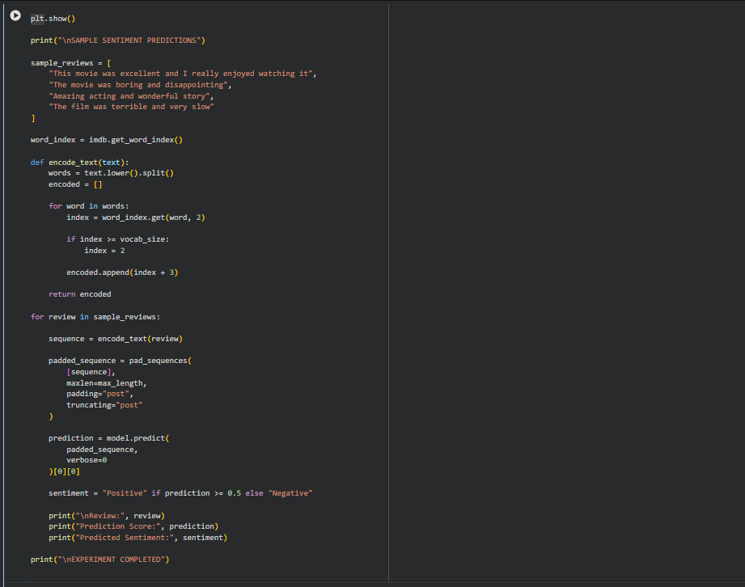

OUTPUT:
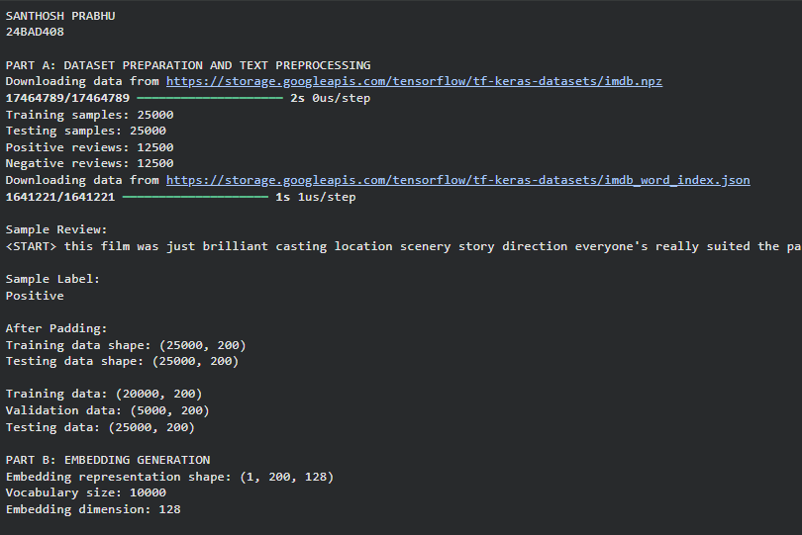

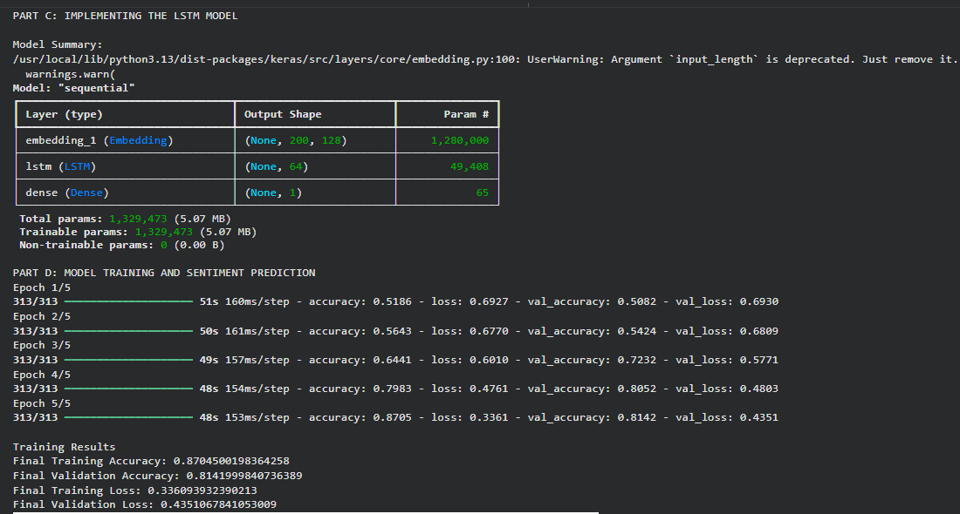

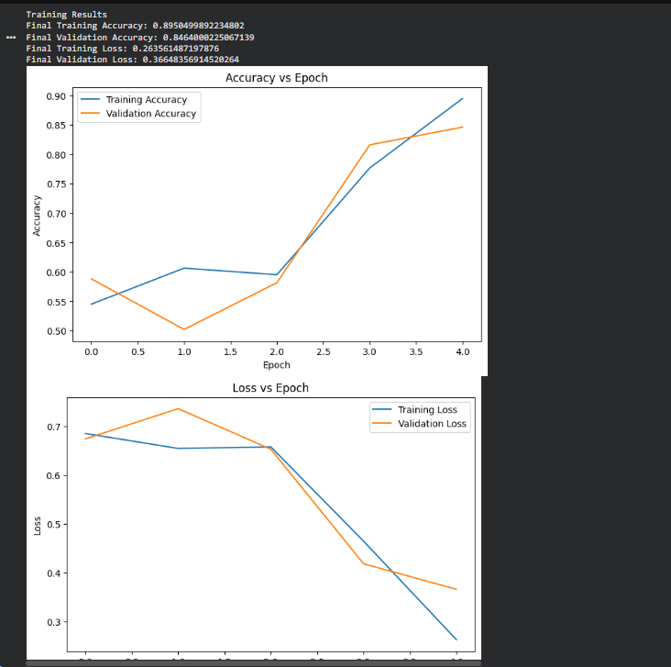
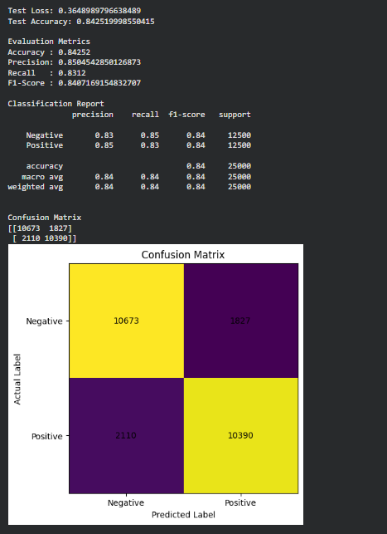

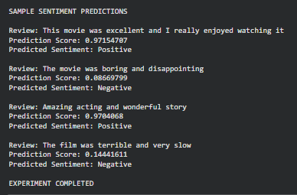

EXPECTED OUTCOME
Students will understand how LSTM networks learn sequential information from textual data and apply them to sentiment classification. Students will learn to perform text preprocessing, tokenization, sequence padding, and embedding generation using NLP libraries. They will build and train an LSTM model and evaluate its ability to classify reviews into positive and negative sentiments.

POST-LAB QUESTIONS (PROVIDE BRIEF ANSWERS TO THE FOLLOWING QUESTIONS)

- What is the role of the memory cell in an LSTM?
The memory cell stores important information from previous time steps and carries it forward through the sequence. It helps the LSTM remember long-term information.
- How does an LSTM overcome the vanishing gradient problem of a Simple RNN?
LSTM uses a memory cell and three gates: input gate, forget gate, and output gate. These control the flow of information and help preserve gradients over long sequences, reducing the vanishing gradient problem.
- What is the purpose of the Embedding layer in the sentiment analysis model?
The Embedding layer converts integer word IDs into dense vector representations. It allows the LSTM to learn meaningful relationships between words.
- How does padding affect the input to an LSTM network?
Padding makes all text sequences equal in length. This allows them to be processed together in batches by the LSTM. Padding values do not represent actual words.
- What happens when the LSTM model is trained for too many epochs?
Training for too many epochs can cause overfitting. The model may perform very well on the training data but perform poorly on unseen test data.
- Why are precision, recall, and F1-score useful in addition to accuracy?
Accuracy gives the overall percentage of correct predictions. Precision measures how many predicted positive results are actually positive, while recall measures how many actual positive results are correctly identified. F1-score combines precision and recall into a single measure.
- Give one limitation of using LSTM for sentiment analysis.
One limitation is that LSTM models can require more computational time and resources for training compared with simpler models.

SUGGESTIONS FOR DATASETS
- IMDB Movie Reviews – https://ai.stanford.edu/~amaas/data/sentiment/
- SST-2 (Stanford Sentiment Treebank) – https://huggingface.co/datasets/stanfordnlp/sst2
- Twitter Sentiment Analysis – https://www.kaggle.com/c/twitter-sentiment-analysis
- Stanford Sentiment Treebank (SST) – https://huggingface.co/datasets/stanfordnlp/sst
- Amazon Product Reviews – https://huggingface.co/datasets/amazon_polarity
- Yelp Polarity Reviews – https://huggingface.co/datasets/fancyzhx/yelp_polarity

GITHUB LINK:

ASSESSMENT
Description | Max Marks | Marks Awarded
Pre Lab Exercise | 5
In Lab Exercise | 10
Post Lab Exercise | 5
Viva | 10
Total | 30
Faculty Signature

